**1.  You will need to produce a document that explains:**

**A) Were you successful in attempting to create a machine-learning model to predict malignant tumors?**

Yes the model is 96% accurate.

**B) The hospitals lawyers are VERY careful and are worried about the accuracy of your model.  You'll need to inform them of the risks of using your system, and possibly convince them of its safety.**

**1). How good is your model?**

True positive rate is much higher than the false positive rate.

[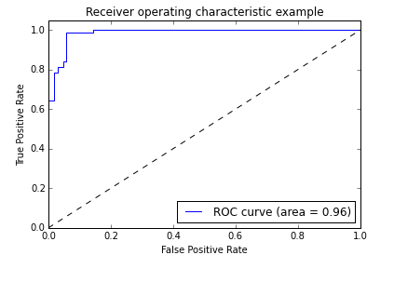](https://cloud.githubusercontent.com/assets/10646127/6906783/8bfabf1a-d6f6-11e4-8c65-8075b25614cd.png)

**2.  How likely is it falsely predicts breast cancer?**

96% accurate and 4% inaccurate.

**3.  How likely is it to miss a malignant case?**

4 times out of 100.

**C) The Chief Oncologist needs to be convinced that the system is making 'realistic' choices and wants to understand which variables are the most important in predicting cancer.   Explain or show the Doctor which variables are most important.**

Variables that are the most important in predicting breast cancer

